- Add a new page on the top of the header named “About us.” Use the About Us document as the content for this page.

- Add this sentence on the top of the Home page; you may need to change the photo or write the sentence in a transparent background.

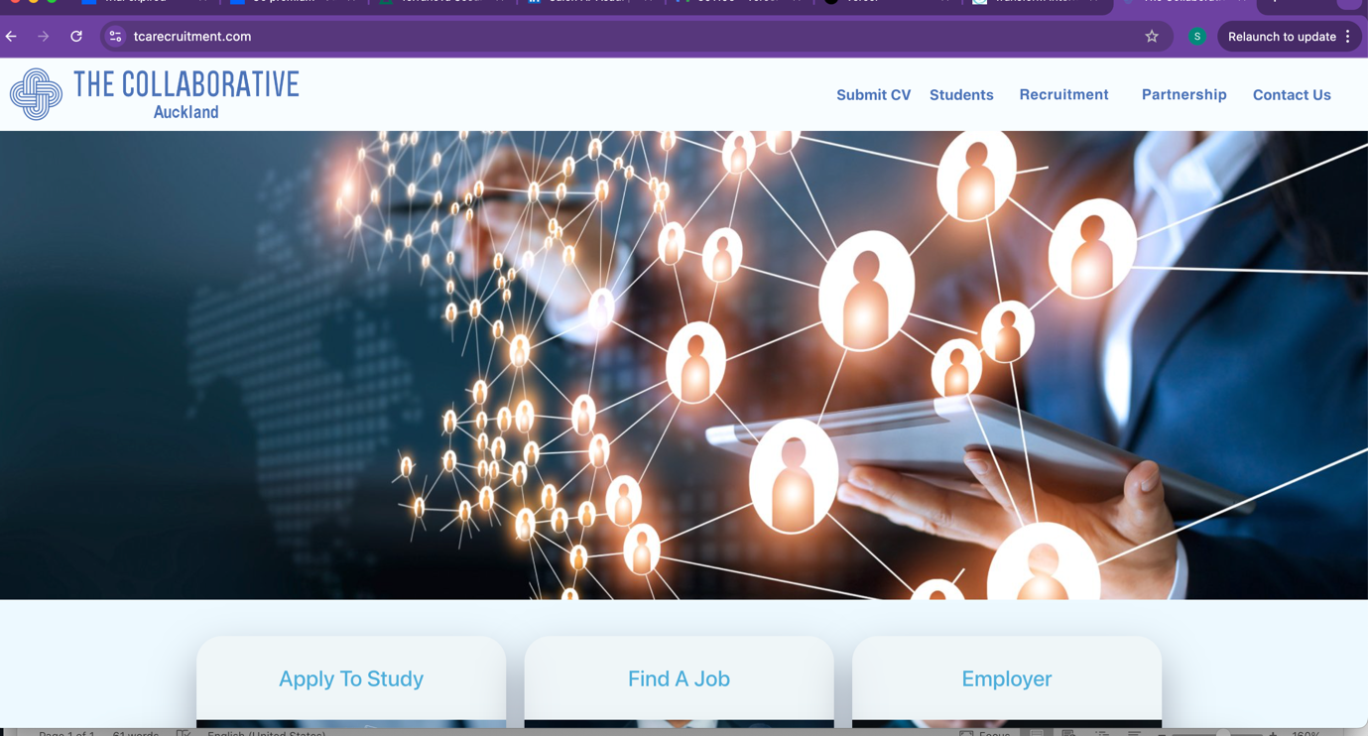
Shaping Global Leaders: The Collaborative, in partnership with the GCC, provides a comprehensive suite of services—from recruiting international students and educators to offering accredited professional training programs. We expertly place top-tier talent in leading teaching roles and prestigious universities worldwide.

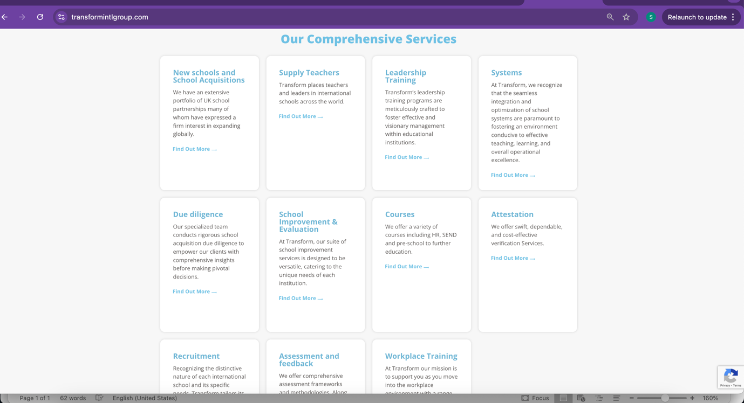
- Add the services list we have provided in the “Our services” document on the front page, just like this page shown below.
- Add the above services to the drop-down list under the partnership and recruitment heading at the top of the page.

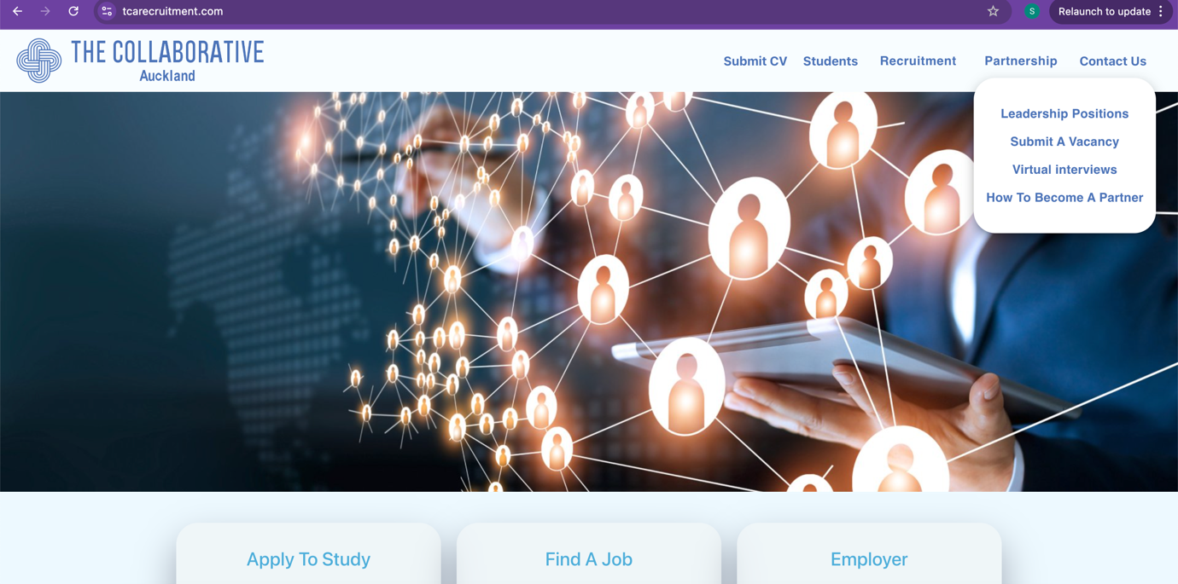

- Use the “The Benefits of Working in the Gulf” document and replace the information on the page “Top 10 reasons to work in Kuwait) under career hub.
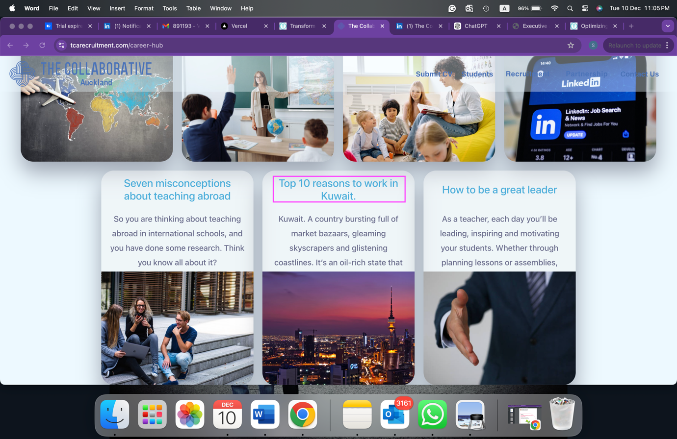

- Delete the “why teaching abroad was the best decision of my life…” page. 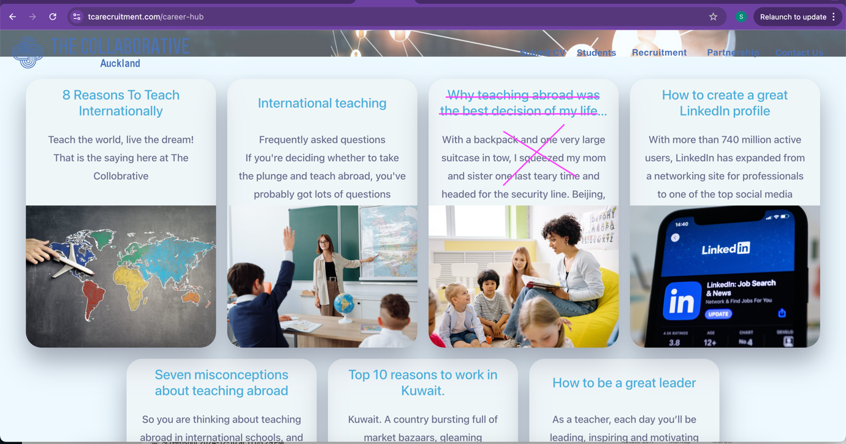

- Delete this image from “How to become our partner” and replace it with “Corporate Leadership Training.” Content is found in our services page.

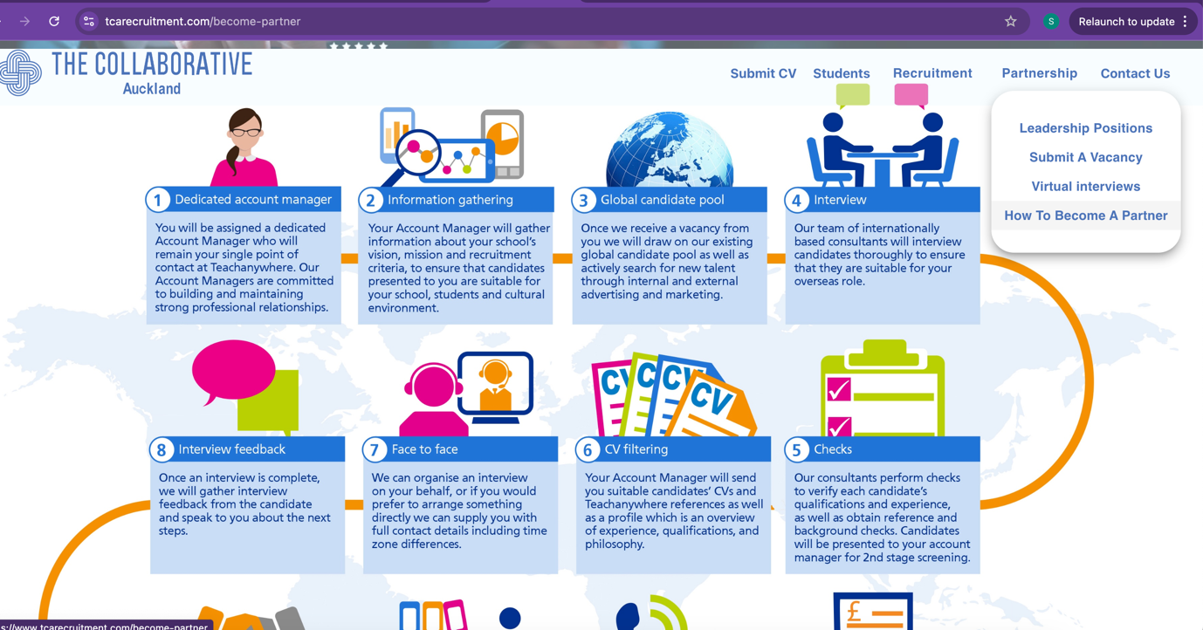

- The document “word editing” has page screenshots requiring you to change or delete some words.
- SEO optimisation and Mobile friendly if possible.

